Name

Mathematics Advanced Year 12
The Fundamental Theorem of Calculus

Book 1 |  | Version: 260409  Feedback:  https://MrDingMaths.com
Contents
Syllabus Content 2
Primitive Functions 3
Primitives of Power Functions 6
Finding the Specific Primitive using Initial Conditions 9
Area Under a Curve 10
The Fundamental Theorem of Calculus 13

Syllabus Content
MAV-12-05 solves problems involving indefinite and definite integrals
Primitive functions
- Define a primitive of a function $f(x)$ as a function $F(x)$ whose derivative $F'\left(x\right)=f(x)$ and recognise the process of finding the primitive as the reverse of differentiation
- Recognise that a function whose derivative is everywhere zero is a constant function
- Prove by differentiation that a primitive of $f\left(x\right)=x^{n}$ is $F\left(x\right)=\frac{x^{n+1}}{n+1}$, for all real $n≠-1$
- Prove by differentiation that if $F(x)$ and $G(x)$ are primitives of $f(x)$ and $g(x)$, and $k$ is a constant, then $F\left(x\right)+G(x)$ is a primitive of $f\left(x\right)+g(x)$, and $kF(x)$ is a primitive of $kf(x)$
- Recognise that primitives of a function $f(x)$ are not unique, and that any two primitives of $f(x)$ differ by a constant, so that if $F(x)$ is a primitive of $f(x)$, the general primitive of $f(x)$ is $F\left(x\right)+C$, for some constant $C$
- Determine the primitive of a given function $f(x)$, where $f(x)$ is a sum of functions of the form $kx^{n}$ for all real $n≠-1$
- Determine the primitive function for functions of the form $f\left(x\right)={\left(ax+b\right)}^{n}$, for all real $n≠-1$, where $a$ and $b$ are constants
- Use algebraic manipulation to express given functions in forms suitable for determining primitive functions
- Determine $f(x)$, given $f'(x)$ and an initial condition $f(a)=b$ where $a$ and $b$ are constants
The definite integral
- Examine for a function $f(x)$, which indicates the rate of change of a quantity, the meaning of $\sum_{a}^{b}{f\left(x\right)Δx}$, where the interval $a≤x≤b$ is divided into subintervals of length $Δx$, and describe $\sum_{a}^{b}{f\left(x\right)Δx}$ as an estimate of the total change in that quantity over the interval $a≤x≤b$
- Consider the definite integral as $\int_{a}^{b}{f(x)}dx=\lim_{Δx→0}{\sum_{a}^{b}{f\left(x\right)Δx}}$, noting that this implies that the result of a definite integral will be negative when $f\left(x\right)≤0$ throughout the interval $a≤x≤b$
- Define informally that a function is continuous on the interval $a≤x≤b$ if it can be drawn between the two endpoints of the interval without taking the pen off the paper
- Graph the region between the continuous function $y=f\left(x\right)$ and the $x$-axis, where $f\left(x\right)≥0$ on the interval $a≤x≤b$
- Use a graphing application to compare different methods of approximating the area, $A$, of the region between the continuous function $y=f(x)$ and the $x$-axis, where $f\left(x\right)≥0$ on the interval $a≤x≤b$, by summing the areas of trapezia or rectangles each of width $Δx=\frac{b - a}{n}$ and approximate height $f\left(x\right)$ for any $x$ lying in its base, and observe the effect on the precision of the approximation of $A$ as the number $n$ of subintervals of $a≤x≤b$ increases, that is as $Δx→0$
- Evaluate the definite integral $∫_{a}^{b}f\left(x\right)dx$ by calculating areas using geometrical formulas, where the shape of $f(x)$ allows such calculations, in cases where $f\left(x\right)≥0$throughout $a≤x≤b$, $f\left(x\right)≤0$throughout $a≤x≤b$ or where $f(x)$ changes sign in the interval $a≤x≤b$
The fundamental theorem of calculus
- Consider the function defined by $A\left(x\right)=\int_{a}^{x}{f\left(t\right)d}t$ and use a graphing application to recognise that $A(x)$ is a primitive of $f(x)$
- Recognise the Fundamental Theorem of Calculus as $\int_{a}^{b}{f}\left(x\right)dx=\left[F(x)\right]{b \atop a}=F\left(b\right)-F\left(a\right)$ for a continuous function $f$ on the interval $a≤x≤b$ where $F(x)$ is any primitive of $f\left(x\right)$

Primitive Functions

- Primitive Function $F\left(x\right)$
A primitive function, or antiderivative, of $f\left(x\right)$ is a function $F\left(x\right)$ such that:

$$F^{'}\left(x\right)=f\left(x\right)$$

Finding a primitive is the reverse of differentiation.
Examples:
$$f\left(x\right)=4x^{3} \\ F\left(x\right)=x^{4}$$ | $$f\left(x\right)=x^{2} \\ F\left(x\right)=\frac{x^{3}}{3}$$ | $$f\left(x\right)=\sin{x} \\ F\left(x\right)=-\cos{x}$$
- The booklet examples will use $f\left(x\right)$ as the primitive and $f^{'}\left(x\right)$ as the derivative until you learn about the definite integral.

- Power Rule for Primitives
The power rule for primitives:
If $f'\left(x\right)=x^{n}$, then $f\left(x\right)=$ $\frac{x^{n+1}}{n+1}$

Add 1 to the power, then divide by the new power.
- You cannot use this rule when $n=-1$

- Identify a possible primitive function
Find a possible primitive function $f\left(x\right)$ given $f'\left(x\right)$:
$$f'\left(x\right)=x^{3}$$  $$f\left(x\right)=\frac{x^{4}}{4}$$ | $$f'\left(x\right)=x^{4}$$  $$f\left(x\right)=\frac{x^{5}}{5}$$ | $$f'\left(x\right)=x^{-7}$$  $$f\left(x\right)=-\frac{x^{-6}}{6}$$
Find a possible primitive function $f\left(x\right)$ given $f'\left(x\right)$:
- $f'\left(x\right)=x^{6}$ | - $f'\left(x\right)=x^{57}$ | - $f'\left(x\right)=x^{-2}$
- $f'\left(x\right)=2$ | - $f'\left(x\right)=x^{-1}$ | - $f'\left(x\right)=0$
- Constant of Integration
When we differentiate, constants disappear.
For example: For $f\left(x\right)=x^{3}+10$, $f^{'}\left(x\right)=3x^{2}$
For $f\left(x\right)=x^{3}-23$, $f^{'}\left(x\right)=3x^{2}$

Therefore, when finding primitives, we must add a constant of integration, $+C$, to represent all possible primitives.
$f\left(x\right)+C$ is called the general primitive. Usually when we are asked to find the primitive of a function, we are finding the general primitive.

When $f'\left(x\right)=0$, the primitive is $f\left(x\right)=C$

- Identify the general primitive function
- $f'\left(x\right)=x^{3}$  $f\left(x\right)=$ | - $f'\left(x\right)=0$ | - $f'\left(x\right)=x^{9}$
- $f'\left(x\right)=x^{-12}$ | - $f'\left(x\right)=x^{15}$ | - $f'\left(x\right)=x$

- Primitives of Sums and Constant Multiples
The primitive of $f'\left(x\right)+g'\left(x\right)$ is:  $f\left(x\right)+g\left(x\right)$  Find the primitives separately. | The primitive of $kf'\left(x\right),$where $k∈R$, is:  $$kf\left(x\right)$$  Multiply the primitive by the factor.

- Example Find the general primitive of a simple power function
Find the general primitives of the following:
$$f'\left(x\right)=x^{3}+x$$  $$f\left(x\right)=\frac{x^{4}}{4}+\frac{x^{2}}{2}+C$$ | $$f'\left(x\right)=9x^{4}$$  $$f\left(x\right)=\frac{9x^{5}}{5}+C$$

- Guided Practice
Find the general primitives of the following:
- $f'\left(x\right)=x^{2}+x+1$  $$f\left(x\right)=\frac{x^{3}}{3}+\frac{x^{2}}{2}+x+C$$ | - $f^{'}\left(x\right)=5x^{3}+7$  $$\frac{5x^{4}}{4}+7x+C$$
- $f^{'}\left(x\right)=$ $\frac{1}{x^{2}}$  $$-\frac{1}{x}+C$$ | - $f^{'}\left(x\right)=\sqrt{x}$  $$\frac{2\sqrt{x^{3}}}{3}+C$$

- Key Ideas
- A ………………… of $f\left(x\right)$ is a function $F\left(x\right)$ such that $F^{'}\left(x\right)=f\left(x\right)$.
- When finding the general primitive, we must add ………… because constants disappear when we differentiate.
- The primitive of $x^{n}$ is …………………
- The primitive of $kf\left(x\right)$ is ………………
- The primitive of $f\left(x\right)+g\left(x\right)$ is ……………………

Foundation
- Find the primitive of each function.
- $x⁶$  $$\frac{x^{7}}{7}+ C$$ | - $x³$  $$\frac{x^{4}}{4}+ C$$ | - $x¹⁰$  $$\frac{x^{11}}{11}+ C$$ | - $3x$  $$\frac{3x^{2}}{2}+ C$$
- $5$  $$5x + C$$ | - $5x^{9}$  $$\frac{x^{10}}{2}+ C$$ | - $21x⁶$  $$3x⁷ + C$$ | - $0$  $$C$$

- Find the primitive of each function.
- $x² + x⁴$  $\frac{x^{3}}{3}+\frac{x^{5}}{5}+ C$ | - $4x³ - 5x⁴$  $x^{4}- x^{5}+ C$ | - $2x² + 5x⁷$  $$\frac{2x^{3}}{3}+\frac{5x^{8}}{8}+ C$$
- $x² - x + 1$  $\frac{x^{3}}{3}-\frac{x^{2}}{2}+ x + C$ | - $3 - 4x + 16x⁷$  $3x - 2x^{2}+ 2x^{8}+ C$ | - $3x² - 4x³ - 5x⁴$  $$x^{3}- x^{4}- x^{5}+ C$$

- Find the primitive of each function after expanding.
- $x(x - 3)$  $$\frac{x^{3}}{3}-\frac{3x^{2}}{2}+ C$$ | - $(x + 1)(x - 2)$  $$\frac{x^{3}}{3}-\frac{x^{2}}{2}- 2x + C$$ | - $(3x - 1)(x + 4)$  $$x^{3}+\frac{11x^{2}}{2}- 4x + C$$
- $x²(5x³ - 4x)$  $$\frac{5x^{6}}{6}- x^{4}+ C$$ | - $2x³(4x⁴ + 1)$  $$x^{8}+\frac{x^{4}}{2}+ C$$ | - $(x - 3)(1 + x²)$  $$\frac{x^{2}}{2}+\frac{x^{4}}{4}- 3x - x^{3}+ C$$

- Write each function using a negative power of $x$.
Then find the primitive function, writing it as a fraction without a negative index.
- $\frac{1}{x^{2}}$  $$-\frac{1}{x}+ C$$ | - $\frac{1}{x^{3}}$  $-\frac{1}{2x^{2}}+ C$ | - $-\frac{3}{x^{4}}$  $$\frac{1}{x^{3}}+ C$$ | - $\frac{1}{x^{2}}-\frac{1}{x^{3}}$  $$-\frac{1}{x}+\frac{1}{2x^{2}}+ C$$

- Write each function using a fractional index, and hence find the primitive.
- $\sqrt{x}$  $\frac{2x^{\frac{3}{2}}}{3}+ C$ | - $\frac{1}{\sqrt{x}}$  $2\sqrt{x}+ C$ | - $\sqrt[3]{x}$  $$\frac{3x^{\frac{4}{3}}}{4}+ C$$ | - $\sqrt[5]{x^{3}}$  $$\frac{5x^{\frac{8}{5}}}{8}+ C$$

- Express $y$ in terms of $x$.
$$\frac{dy}{dx}= 5x^{4}- 9$$  $$y=x^{5}-9x+C$$ | $$\frac{dy}{dx}= x^{-4}- 2x^{-2}$$  $$y=-\frac{1}{3x^{3}}+\frac{2}{x}+C$$ | $$\frac{dy}{dx}=\frac{x^{3}}{5}- x^{2}$$  $$y=\frac{x^{4}}{20}-\frac{x^{3}}{3}+C$$ | $$\frac{dy}{dx}= x^{3}-\frac{2x}{3}+ 1$$  $$y=\frac{x^{4}}{4}-\frac{x^{2}}{3}+x+C$$

- Find the antiderivative, writing your answer with positive non-fractional indices.
- $\sqrt{x}$  $$\frac{2\sqrt{x^{3}}}{3}+C$$ | - $x^{-3}$  $$-\frac{1}{x^{2}}+C$$ | - $\frac{1}{x^{8}}$  $$-\frac{1}{7x^{7}}+C$$ | - $\frac{1}{\sqrt{x}}+\frac{2}{\sqrt[3]{x^{2}}}$  $$2\sqrt{x}+6\sqrt[3]{x}+C$$

Primitives of Power Functions

- Investigation Primitive of linear transformations of power functions
We are investigating the primitive of linear transformations of power functions: ${\left(ax+b\right)}^{n}$
Differentiate the following:
- $f\left(x\right)={\left(2x+1\right)}^{5}$  $f^{'}\left(x\right)=$ | - $f\left(x\right)={\left(4x-7\right)}^{9}$  $f^{'}\left(x\right)=$ | - $f\left(x\right)={\left(3-2x\right)}^{8}$  $f^{'}\left(x\right)=$
Look at your three derivatives.
In each case, what two numbers multiplied together to give the coefficient out the front?
We multiply by the …………… and the ………………… of $x$.

Using your derivatives, find the primitives of:
- $f^{'}\left(x\right)=10{\left(2x+1\right)}^{4}$  $f\left(x\right)=$ | - $f^{'}\left(x\right)=36{\left(3x-7\right)}^{8}$ | - $f\left(x\right)=-16{\left(3-2x\right)}^{7}$
Look at your three primitives.
In each case, what numbers do we divide to get the primitive?
We divide by the ……………… plus 1, and the ……………… of $x$.

But what happens when we are missing the coefficient at the front?

$$f^{'}\left(x\right)={\left(2x+1\right)}^{4}$$

We need to ‘give ourselves’ the constant term, then divide to keep the expression the same.

$$f^{'}\left(x\right)=\frac{1}{10}⋅10{\left(2x+1\right)}^{4} \\ ∴f\left(x\right)=\frac{1}{10}{\left(2x+1\right)}^{5}$$

Confirm this works by differentiating $f\left(x\right)=$ $\frac{1}{10}$ ${\left(2x+1\right)}^{5}$.

- Investigation Primitive of linear transformations of power functions
To find the primitive of ${\left(ax+b\right)}^{n}$, increase the power by 1 and divide by the product of the new power and the coefficient of $x$.
Find the primitive of $f'(x) = (4x - 7)⁸$

Let’s see why this always works.
Let $f\left(x\right)={\left(ax+b\right)}^{n+1}$. Differentiate using the chain rule.

So ${\left(ax+b\right)}^{n+1}$ is the primitive of $a\left(n+1\right){\left(ax+b\right)}^{n}.$

If we only have ${\left(ax+b\right)}^{n}$ without the coefficient of $a\left(n+1\right)$ in front, we need to compensate:

$f^{'}\left(x\right)={\left(ax+b\right)}^{n}$
$$f^{'}\left(x\right)=\frac{1}{a\left(n+1\right)}⋅a\left(n+1\right){\left(ax+b\right)}^{n}$$
$$∴f\left(x\right)=\frac{1}{a\left(n+1\right)}{\left(ax+b\right)}^{n+1}$$

- Primitive of Linear Transformations of Power Functions $f\left(x\right)={\left(ax+b\right)}^{n}$
$$f^{'}\left(x\right)={\left(ax+b\right)}^{n} \\ f\left(x\right)=\frac{{\left(ax+b\right)}^{n+1}}{a\left(n+1\right)}$$
Increase the power by 1, divide by the new power and the coefficient of $x$.

- Example Find the primitive of a linear transformation of a power function
Find the general primitives of the following:
$$f'\left(x\right)={\left(3x+1\right)}^{4}$$  $$f\left(x\right)=\frac{{\left(3x+1\right)}^{5}}{3\left(5\right)}+C$$  $$=\frac{{\left(3x+1\right)}^{5}}{15}+C$$ | $$f'\left(x\right)=\sqrt{1-5x}$$  $$={\left(1-5x\right)}^{\frac{1}{2}}$$  $$f\left(x\right)=\frac{{\left(1-5x\right)}^{\frac{3}{2}}}{-5\left(\frac{3}{2}\right)}+C$$  $$=-\frac{2\sqrt{{\left(1-5x\right)}^{3}}}{15}+C$$

- Guided Practice
Find the general primitives of the following:
- $f'\left(x\right)={\left(6x+5\right)}^{2}$ | - $f'\left(x\right)={\left(1-3x\right)}^{6}$
- $f'\left(x\right)=$ $\frac{1}{{\left(x+1\right)}^{2}}$ | - $f'\left(x\right)=\sqrt{2x+1}$

Foundation
- Find the primitive of each function.
- $(x + 1)³$  $$\frac{{\left(x + 1\right)}^{4}}{4}$$ | - $(x - 2)⁵$  $$\frac{{\left(x - 2\right)}^{6}}{6}+ C$$ | - $(x + 5)²$  $$\frac{{\left(x + 5\right)}^{3}}{3}+ C$$ | - $(2x + 3)⁴$  $$\frac{{\left(2x + 3\right)}^{5}}{10}+ C$$
- $(3x - 4)⁶$  $$\frac{{\left(3x - 4\right)}^{7}}{21}+ C$$ | - $(5x - 1)³$  $$\frac{{\left(5x - 1\right)}^{4}}{20}+ C$$ | - $(1 - x)³$  $$-\frac{{\left(1 - x\right)}^{4}}{4}+ C$$ | - $(1 - 7x)³$  $$-\frac{{\left(1 - 7x\right)}^{4}}{28}+ C$$
- $\frac{1}{(x - 2)⁴}$  $$-\frac{1}{3{\left(x - 2\right)}^{3}}+ C$$ | - $\frac{1}{(1 - x)¹⁰}$  $$\frac{1}{9{\left(1 - x\right)}^{9}}+ C$$ | - $5(1 - x)³$  $$-\frac{{5\left(1 - x\right)}^{4}}{4}+ C$$ | - $\frac{7}{{\left(x - 2\right)}^{4}}$  $$-\frac{7}{3{\left(x - 2\right)}^{3}}+ C$$

- Find the primitive of each function.
- $\sqrt{x+1}$  $$\frac{2{\left(x + 1\right)}^{\frac{3}{2}}}{3}+ C$$ | - $\sqrt{x-5}$  $$\frac{2{\left(x - 5\right)}^{\frac{3}{2}}}{3}+ C$$ | - $\sqrt{1-x}$  $-\frac{2{\left(1 - x\right)}^{\frac{3}{2}}}{3}+ C$ | - $\sqrt{2x-7}$  $$\frac{{\left(2x - 7\right)}^{\frac{3}{2}}}{3}+ C$$

Finding the Specific Primitive using Initial Conditions

- The Specific Primitive
An initial condition is a known point on the curve $y=f(x).$
Given $fʹ(x)$ and an initial condition $f(a) = b$, we can find the value of $C$ and determine the unique primitive function $f(x).$
1. Find the general primitive: $f\left(x\right)=[primitive of f'(x)] +C$
2. Substitute the initial condition: $f\left(a\right)=b$
3. Solve for $C$
4. Write the specific primitive function $f(x)$ with the value of $C$

- Example find specific primitive function using initial condition
Given $f'(x) = 4x³ - 6x$ and $f(2)=7$, find $f(x).$
1. $f\left(x\right)=x^{4}-3x^{2}+C$
2. $7={\left(2\right)}^{4}-3{\left(2\right)}^{2}+C$
3. $7=8-12+C$
$C=3$
4. $f\left(x\right)=x^{4}-3x^{2}+3$

- Guided Practice
- Given $f'(x)=3x²+4x$ and $f(1)=8$, find $f(x).$  $$f\left(x\right)=x^{3}+2x^{2}+5$$ | - Given $f'(x)=6x²-2x+1$ and $f(0)=3$, find $f(x)$.  $$f(x)=2x³-x²+x+3$$
- Given that $\frac{dy}{dx}$ $={\left(2x+1\right)}^{4}$ and $y=4$ when $x=-0.5$, find $y$ as a function of $x$.  $$y =\frac{{\left(2x + 1\right)}^{5}}{10}+ 4$$ | - Given $f^{'}\left(x\right)=12{\left(x-1\right)}^{2},$and  $f\left(1\right)=0$, find $f\left(4\right)$  $$f(4) = 108$$

Foundation
- Find $y$ as a function of $x$ if:
- $y'=2x+3$ and $y=3$ when $x=0$  $$y=x²+3x+3$$ | - $y'=9x²+4$ and $y=5$ when $x=1$  $$y=3x³+4x-2$$ | - $y'=3x²-4x+7$ and  $y=0$ when $x=0$  $$x³-2x²+7x$$

- If $\frac{dy}{dx}$ $=x^{3}-3x^{2}+5$ and $y=4$ when $x=1$, find an equation for $y$ in terms of $x$.

$$y =\frac{x^{4}}{4}- x^{3}+ 5x -\frac{1}{4}$$
- If $f'(x)=4x-7$and $f(2)=5$, find an equation for $y=f(x)$.

$$f(x) = 2x² - 7x + 11$$
- Given $f'(x) = 3x² + 4x - 2$ and $f(-3)=4$, find the value of $f(1)$.

$$f(1) = 8$$
- Given that the gradient of the tangent to a curve is given by $\frac{dy}{dx}$ $=2-6x$ and the curve passes through $(-2, 3),$ find the equation of the curve.

$$y = 2x - 3x² + 19$$

- Find $y$ as a function of $x$ if $\frac{dy}{dx}$ $=\sqrt{x}$ and:
- $y=1$ when$x=0$  $$y =\frac{2x^{\frac{3}{2}}}{3}+ 1$$ | - $y=2$ when $x=9$  $$y =\frac{2x^{\frac{3}{2}}}{3}- 16$$

  - Find the equation of the curve through the origin whose gradient is $\frac{dy}{dx}$ $=3x^{4}-x^{3}+1$.

$$y =\frac{3x^{5}}{5}-\frac{x^{4}}{4}+ x$$
  - Find the curve passing through $(2, 6)$ with gradient function $\frac{dy}{dx}$ $=2+3x²-x^{3}$.

$$y = -\frac{x^{4}}{4}+ x^{3}+ 2x - 2$$
  - Find the curve through the point $\left(\frac{1}{5}, 1\right)$ with gradient function $y' = {\left(2 - 5x\right)}^{3}.$

$$y = -\frac{{\left(2 - 5x\right)}^{4}}{20}+\frac{21}{20}$$

- Find $y$ if $\frac{dy}{dt}$ $= 8t^{3}- 6t^{2}+ 5,$ and $y = 4$when $t = 0$. Hence find $y$ when $t = 2$.

30

- $y'' = 6x + 4$. When $x = 1, y' = 2$and $y = 4$.
  - Find $y'$and use the condition $y' = 2$ when $x = 1$ to find the constant of integration.

$$y^{'}= 3x^{2}+ 4x + C₁$$
$$Sub x = 1, y^{'}= 2:$$
$$2 = 3 + 4 + C_{1},$$
$$so C_{1}= -5$$
$$y^{'}= 3x^{2}+ 4x - 5$$
  - Find $y$ and use the condition $y = 4$ when $x = 1$ to find the second constant.

$$y = x³ + 2x² - 5x + C_{2}$$
$$Sub x = 1, y = 4: 4 = 1 + 2 - 5 + C_{2}$$
$$C_{2}= 6$$
$$y = x³ + 2x² - 5x + 6$$

- A function $f(x)$ has second derivative $f''(x)=2x-10$. Its graph passes through the point $(3, -34),$ and at this point the tangent has a gradient of 20.
  - Show that $f^{'}\left(x\right)= x^{2}- 10x + 41.$
  - Hence find $f(x),$ and show that its graph cuts the $y$-axis at $(0, -121).$

$$f^{''}\left(x\right)= 2x - 10$$
$$f^{'}\left(x\right) = x^{2}- 10x + C$$
$$f'(3) = 20:$$
$$20 = 9 - 30 + C$$
$$C = 41$$
$$f'(x) = x² - 10x + 41$$

$$f\left(x\right)=\frac{x^{3}}{3}- 5x^{2}+ 41x + C$$
$$Sub \left(3, -34\right):$$
$$-34 = 9 - 45 + 123 + C,$$
$$C = -121$$
$$f\left(x\right)=\frac{x^{3}}{3}- 5x^{2}+ 41x - 121$$
$$When x = 0: f\left(0\right)= -121, so the graph cuts the y axis at (0, -121).$$

- If $y^{''}= 8 - 6x$, show that $y = 4x^{2}- x^{3}+ Cx + D$, for some constants $C$ and $D$.
Hence find the equation of the curve given that it passes through the points $(1, 6)$ and $(-1, 8).$
$$y^{''}= 8 - 6x$$
$$y^{'}= 8x - 3x^{2}+ C$$
$$y = 4x^{2}- x^{3}+ Cx + D$$
$$Sub \left(1, 6\right): 6 = 4 - 1 + C + D$$
$$C + D = 3 … (1)$$
$$Sub \left(-1, 8\right): 8 = 4 + 1 - C + D$$
$$-C + D = 3 … \left(2\right)$$
$$\left(1\right)+ \left(2\right): 2D = 6, D = 3.$$
$$C = 0.$$
$$y = -x³ + 4x² + 3$$

Development
- A curve has $\frac{d^{2}y}{dx^{2}}$ $= 8x$ and the tangent at $(-2, 5)$ has an angle of inclination of 45° with the
$x$-axis. Find the equation of the curve.
$$\frac{d^{2}y}{dx^{2}}= 8x$$
$$y^{'}= 4x^{2}+ C_{1}$$
Angle of inclination 45° means gradient = tan 45° = 1.
$$At x = -2, y' = 1: 1 = 16 + C₁, so C₁ = -15.$$
$$y' = 4x² - 15$$

$$y =\frac{4x^{3}}{3}- 15x + C₂$$
$$sub (-2, 5):$$
$$5 = -\frac{32}{3} + 30 + C₂,$$
$$C₂ = -\frac{43}{3}.$$
$$y =\frac{4x^{3}}{3}- 15x -\frac{43}{3}$$

- The tangent to a curve with $\frac{d^{2}y}{dx^{2}}$ $= 2x - 4$ makes an angle of inclination of 135° with the $x$-axis at the point $(2, -4)$. Find its equation.

$$\frac{d^{2}y}{dx^{2}}= 2x - 4$$
$$y^{'}= x^{2}- 4x + C₁$$
Angle of inclination 135° means gradient = tan 135° = −1.
$$At x = 2, y' = -1: -1 = 4 - 8 + C₁, so C₁ = 3.$$
$$y' = x² - 4x + 3$$
$$y =\frac{x^{3}}{3}- 2x^{2}+ 3x + C₂$$
$$Sub (2, -4):$$
$$-4 =\frac{8}{3}- 8 + 6 + C₂,$$
$$C_{2}= -\frac{14}{3}$$
$$y =\frac{x^{3}}{3}- 2x^{2}+ 3x -\frac{14}{3}$$
- A function has a tangent parallel to the line $4x - y - 2 = 0$ at the point $(0, -2)$,
and $f^{''}\left(x\right)= 12x^{2}- 6x + 4.$ Find the equation of the function.

The line $4x - y - 2 = 0$ has gradient $4$.
$$f''(x) = 12x² - 6x + 4$$
$$f^{'}\left(x\right)= 4x³ - 3x² + 4x + C₁$$
At (0, −2), tangent parallel to line so f'(0) = 4: 4 = C₁.
$$f^{'}\left(x\right)= 4x^{3}- 3x^{2}+ 4x + 4$$

$$f\left(x\right)= x⁴ - x³ + 2x² + 4x + C₂$$
Sub (0, −2): −2 = C₂.
$$f\left(x\right)= x^{4}- x^{3}+ 2x^{2}+ 4x - 2$$
- A curve has $\frac{d^{2}y}{dx^{2}}$ $= 6$ and the tangent at $(-1, 3)$ is perpendicular to the line $2x + 4y - 3 = 0$. Find the equation of the curve.

$$\frac{d^{2}y}{dx^{2}}= 6$$
$$y^{'}= 6x + C₁$$
The line $2x + 4y - 3 = 0$ has gradient $-\frac{1}{2}$. Perpendicular gradient = 2.
$$At x = -1, y' = 2: 2 = -6 + C₁, so C₁ = 8.$$
$$y' = 6x + 8$$

$$y = 3x² + 8x + C₂$$
Substitute (−1, 3): 3 = 3 − 8 + C₂, so C₂ = 8.
$$y = 3x^{2}+ 8x + 8$$

- A function has $f'(1) = 3$ and $f(1) = 5$. Evaluate $f(-2)$ given $f''(x) = 6x + 18$.

$$f^{''}\left(x\right)= 6x + 18$$
$$f^{'}\left(x\right)= 3x² + 18x + C₁$$
$$f^{'}\left(1\right)= 3: 3 = 3 + 18 + C^{1}$$
$$C₁ = -18.$$
$$f^{'}\left(x\right)= 3x^{2}+ 18x - 18$$

$$f\left(x\right)=x³ + 9x² - 18x + C₂$$
$$f\left(1\right)= 5:$$
$$5 = 1 + 9 - 18 + C^{2},$$
$$C₂ = 13.$$
$$f(x) = x³ + 9x² - 18x + 13$$
$$f(-2) = -8 + 36 + 36 + 13 = 77$$

Area Under a Curve

- Investigation Area under a curve
Much of calculus was invented to solve the area problem.
How can we find the area bounded by a curved graph and the $x$-axis?
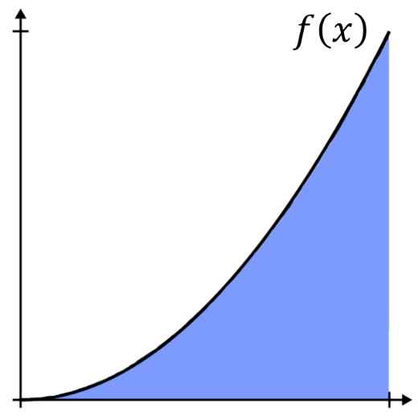

We can estimate by splitting the area into rectangles, then summing the areas:
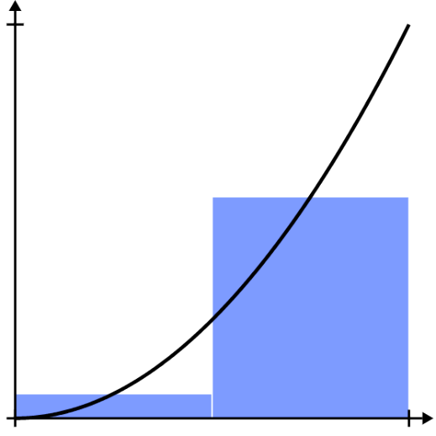
2 rectangles: 10 rectangles Lots of rectangles
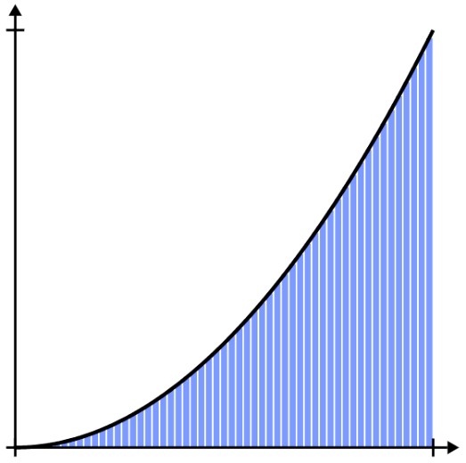
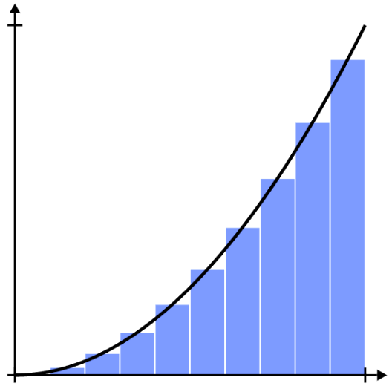

The more rectangles we have, the more ……………… the estimate for area.
If we have infinitely thin rectangles, then we will get the ……………… area.
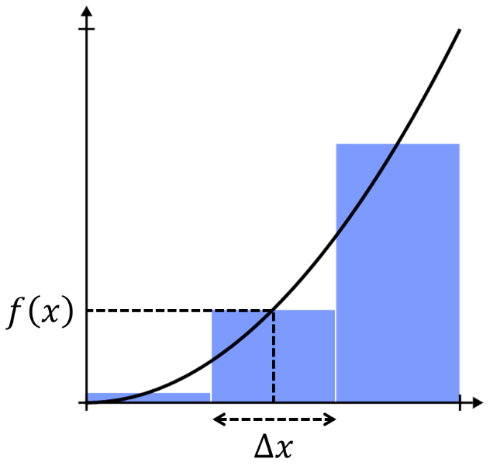
Let the width of each rectangle be $Δx$.
The height of a rectangle is the function value $f\left(x\right)$.

Therefore, the area of one rectangle is: ……………

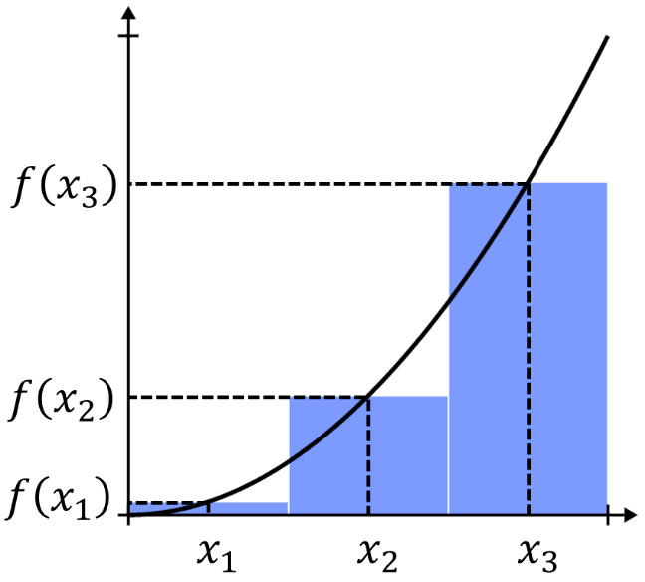
The area of all three rectangles would be:
$f\left(x_{1}\right)Δx$ $+$ ……… $+$ ………
$$=\sum_{a}^{b}{f\left(x\right)Δx}$$
where the interval $a≤x≤b$ is divided into
subintervals of length $Δx$.
This approximation for the area is called the Riemann sum.
- Investigation Area under a curve
$$What would be\sum_{0}^{1}{x^{2} Δx} for 3 subintervals?$$  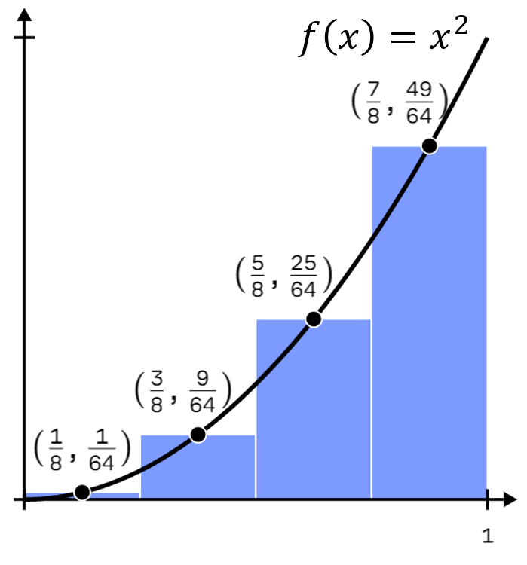  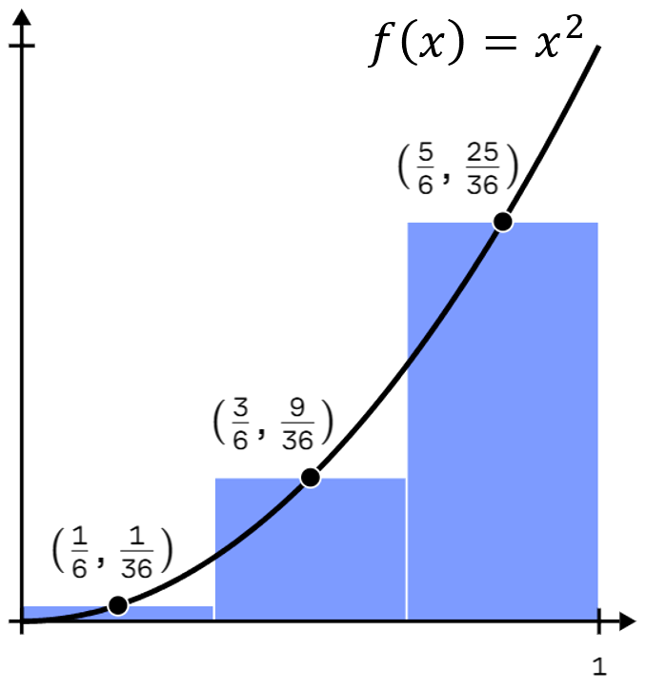 | $$What would be\sum_{0}^{1}{x^{2} Δx} for 4 subintervals?$$

Let’s use a computer to calculate the Riemann sum for more and more subintervals:
$$A≈0.32408$$  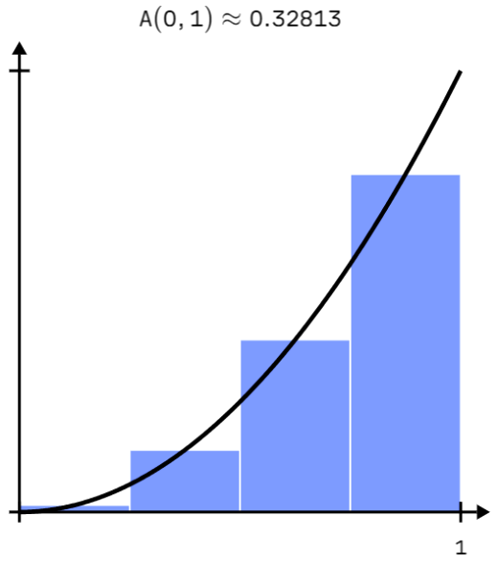  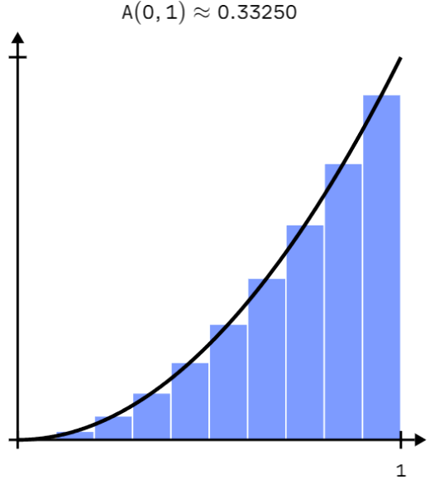  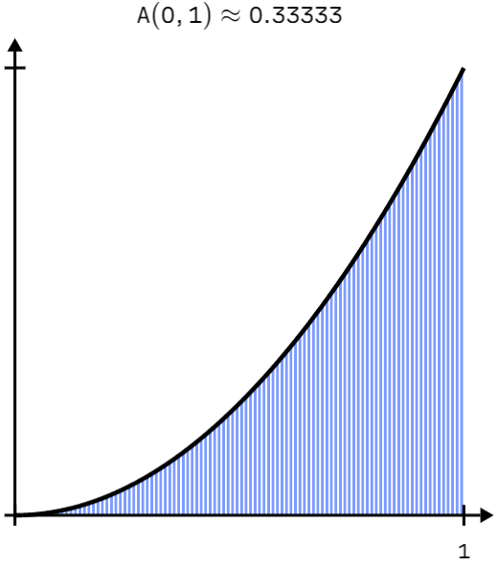  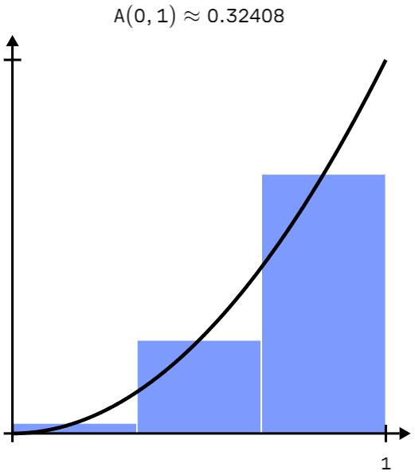 | $$A≈0.32813$$ | $$A≈0.33250$$ | $$A≈0.33333$$
$$What would be\lim_{Δx→0}{\sum_{0}^{1}{x^{2} Δx}}\left(for ∞ subintervals\right)?$$

We call the exact area under a curve, found by summing infinitely thin rectangles,
the definite integral (this is the Riemann sum for infinite subintervals):
$$\lim_{Δx→0}{\sum_{a}^{b}{f\left(x\right) Δx}}$$
$$=\int_{a}^{b}{f\left(x\right)}dx$$
You read this as ‘the integral of $f\left(x\right)$ with respect to $x$, from $x=a$ to $x=b$’
The fancy S integral symbol will be used from now on to show the definite integral.
- The Definite Integral
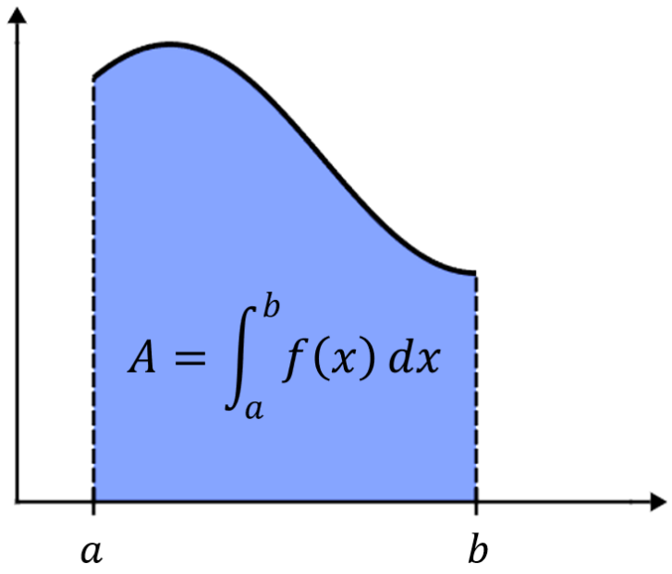
The definite integral is the area between a continuous curve and the $x$ axis for $x∈\left[a,b\right]$

- Area Under a Line and Semicircle
We will start with straightforward examples involving straight lines and semicircles to get used to the notation.
Area of a rectangle | $$A=bh$$ | Area of a trapezium | $$A=\frac{h}{2}\left(a+b\right)$$
Area of a triangle | $$A=\frac{1}{2}bh$$ | Area of a circle | $$A=πr^{2}$$

- Interpret Definite integral notation
Evaluate the area using the given sketch:
$$\int_{0}^{2}{3}dx$$  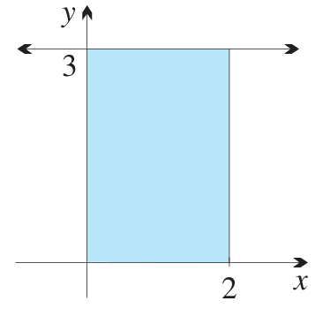 | $$\int_{1}^{4}{\left(x-1\right)}dx$$  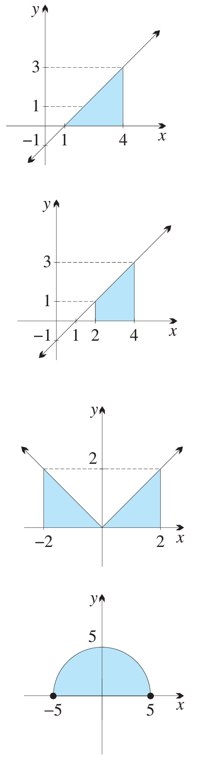 | $$\int_{2}^{4}{\left(x-1\right)}dx$$
$$\int_{-2}^{2}{\left(x+6\right)}dx$$  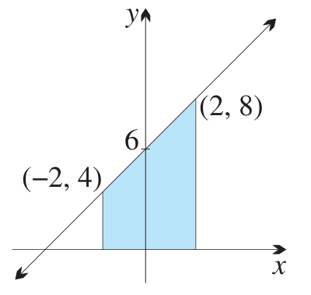 | $$\int_{-2}^{2}{\left|x\right|}dx$$ | $$\int_{-5}^{5}{\sqrt{25-x^{2}}}dx$$

Foundation
- Use area formulae to calculate the sketched definite integrals.
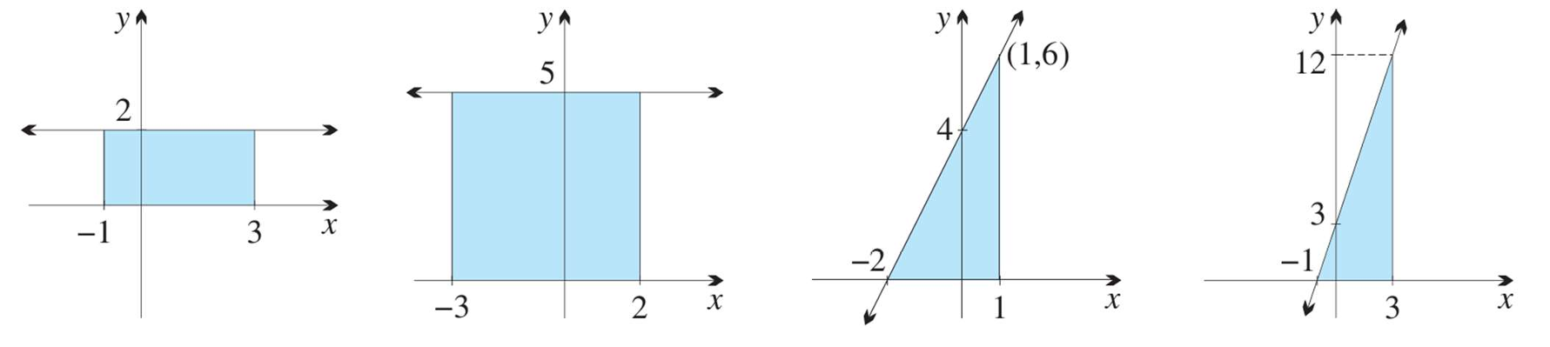  $$\int_{-1}^{3}{2}dx$$  $$8$$ | $$\int_{-3}^{2}{5}dx$$  $$25$$ | $$\int_{-2}^{1}{\left(2x + 4\right)}dx$$  $$9$$ | $$\int_{-1}^{3}{\left(3x + 3\right)}dx$$  $$24$$
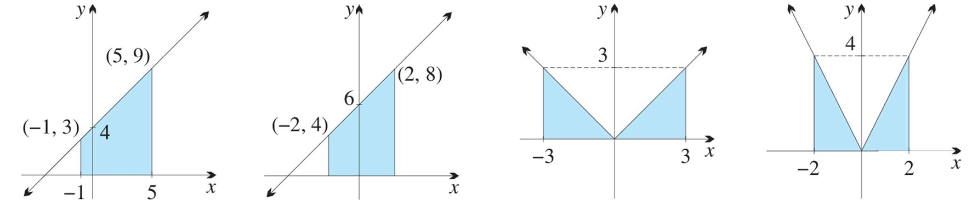  $$\int_{-1}^{5}{\left(x + 4\right)}dx$$  $$36$$ | $$\int_{-2}^{2}{\left(x + 6\right)}dx$$  $$24$$ | $$\int_{-3}^{3}{\left|x\right|}dx$$  $$9$$ | $$\int_{-2}^{2}{\left|2x\right|}dx$$  $$8$$

- Evaluate $\int_{0}^{4}{f\left(x\right)}dx$
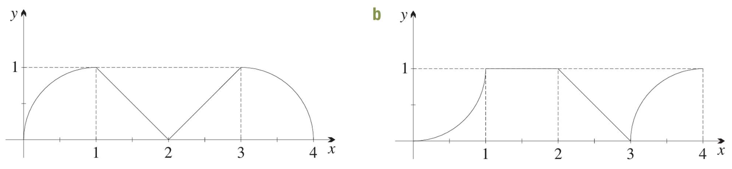  $$1+\frac{π}{2}$$ | $$2.5$$

- Sketch a graph of each definite integral, then use an area formula to calculate it.
$$\int_{-4}^{4}{\sqrt{16 - x^{2}}}dx$$  $$8π$$ | $$\int_{-5}^{0}{\sqrt{25 - x^{2}}}dx$$  $$\frac{25π}{4}$$

The Fundamental Theorem of Calculus

- Review
- Find average velocity using change in displacement
- Given $x\left(0\right)=2$ m and $x\left(5\right)=32$ m, what is the average velocity? | - Given $x\left(3\right)=14$ m and $x\left(9\right)=26$ m, what is the average velocity?

- Calculate displacement from velocity and time
- A car travels at a constant 10 m/s.  How far does it travel in 2 seconds? | - A car travels at a constant 12 m/s.  How far does it travel in 5 seconds?

- Recall the relationship between displacement and velocity
- $x\left(t\right)=5t$  $$v\left(t\right)=$$ | - $x\left(t\right)=5t^{2}+3t$  $$v\left(t\right)=$$ | - $x\left(t\right)=$  $$v\left(t\right)=t^{2}$$

- Investigation The fundamental theorem of calculus
The fundamental theorem of calculus says that:
$$\int_{a}^{b}{f\left(x\right)}dx=F\left(b\right)-F\left(a\right)$$
“The area under a curve equals the difference between the ……………… at the endpoints”
This means you can compute the area algebraically, without calculating sums of rectangles.
We will now demonstrate how the primitive and areas under curves are related.

Consider the following velocity-time graph for a car.
It starts off at a constant velocity, then starts accelerating.
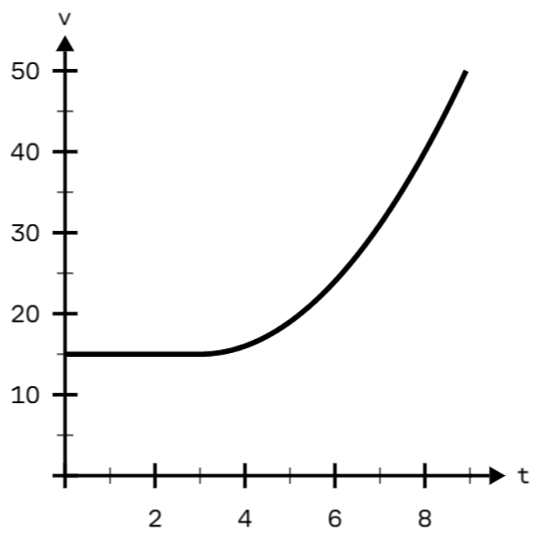
How far does the car travel over the first three seconds?
Since the car is travelling at a constant velocity,
we can use $displacement=velocity×time$
$=$ ( )( )
$=$ ………… m

This happens to be the …………… under the curve!

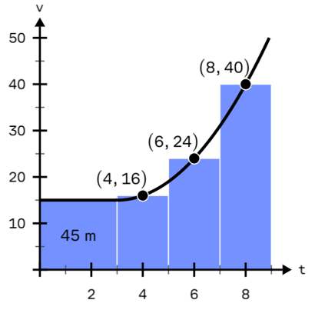
We will estimate how far the car travelled over the next six seconds ($t=3$ to $t=9$).
Since velocity is not constant in this interval, the graph is curved. We will use the Riemann sum:
$displacement=$ ………… $+$ ………… $+$ …………
$=$ ………… m

By taking more and more subintervals, what would be a more accurate calculation for change in displacement?

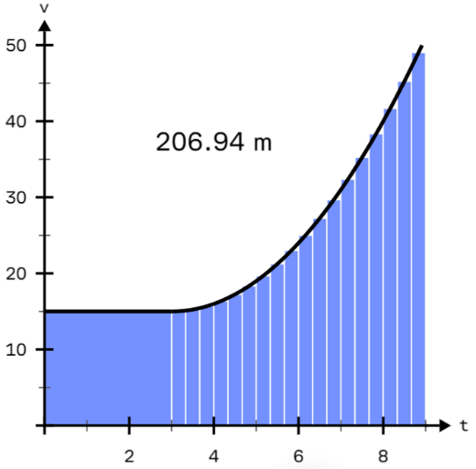
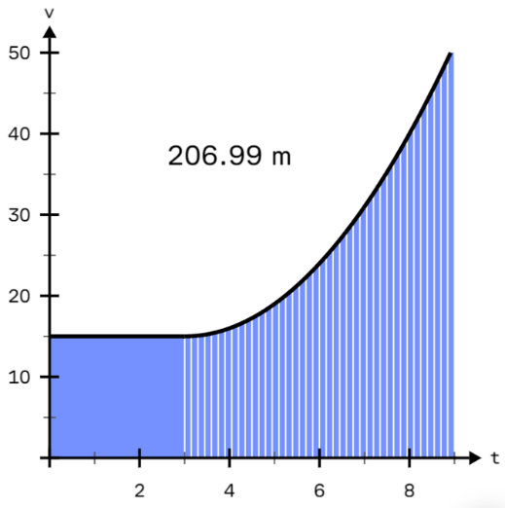
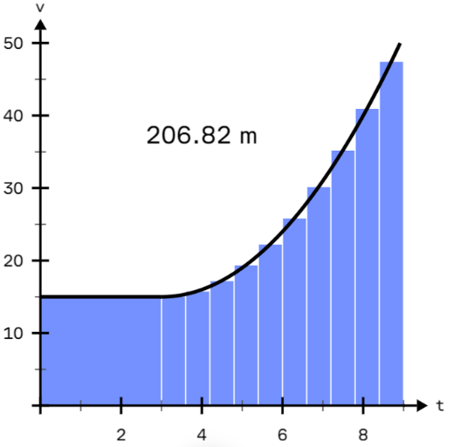
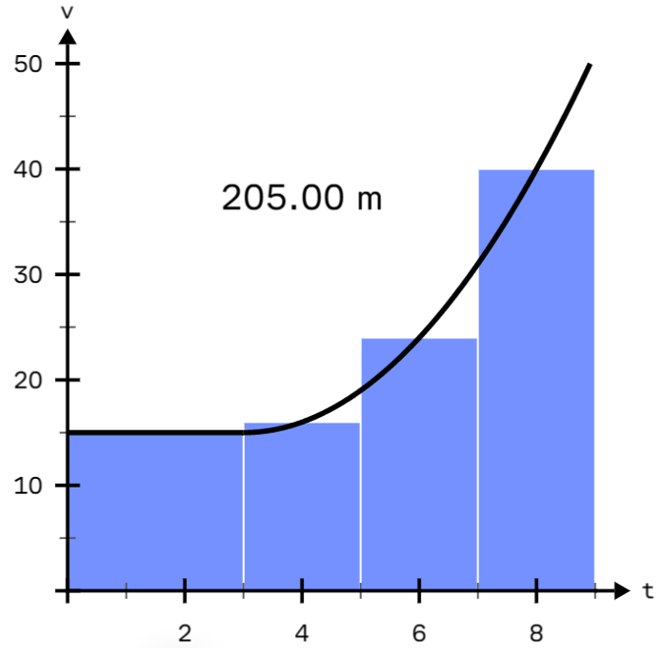

- Investigation The fundamental theorem of calculus
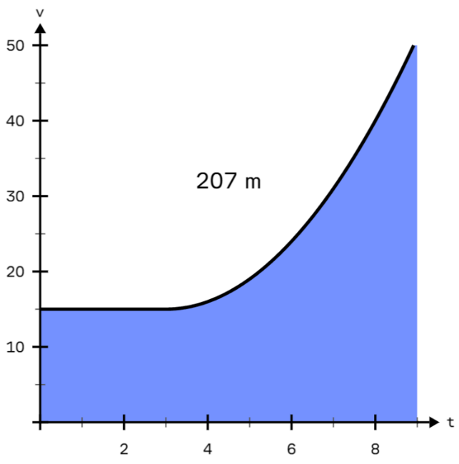
Let the functions for displacement be $x\left(t\right)$ and velocity be $v\left(t\right)$.

From $t=0$ to $t=9$, the car’s displacement changes by 207 m.
We found this by calculating the area under its velocity graph.

$$Change in displacement= \int_{0}^{9}{v\left(t\right)}dt$$

We could also find this change by subtracting the car's
displacement at the two endpoints:
$$Change in displacement=x\left(9\right)-x\left(0\right)$$

Combining these two relationships:
$$\int_{0}^{9}{v\left(t\right)}dt=x\left(9\right)-x\left(0\right)$$

Since velocity is the derivative of displacement, displacement is the ……………… of velocity.

This can apply to any scenario (not just velocity and displacement) and gives us the fundamental theorem of calculus:
$$\int_{a}^{b}{f\left(x\right)}dx=F\left(b\right)-F\left(a\right)$$

- Key Ideas
- Change in displacement $x\left(t\right)$ between $t=a$ and $t=b$ is $x\left(b\right)-$ …………
- The area under a ……………… graph also gives the change in displacement.
- So, change in displacement equals $\int_{a}^{b}{v\left(t\right)}dt=$ ………… $-$ …………
- Since velocity is the derivative of displacement, displacement is the …………… of velocity.
- Therefore, the fundamental theorem of calculus states that $\int_{a}^{b}{f\left(x\right)}dx=F\left(b\right)-F\left(a\right)$, in other words, the area under a curve is the difference between the ……………… at the endpoints.

- The Definite Integral
The definite integral is the area between a continuous curve and the $x$ axis for $x∈\left[a,b\right]$.
It is the difference between the primitives at the endpoints.

$$\int_{a}^{b}{f\left(x\right)}dx=F\left(b\right)-F\left(a\right)$$

- Mathematicians set out $F\left(b\right)-F\left(a\right)$ as ${\left[F\left(x\right)\right]}_{a}^{b}$

- Always show the substitution. Put brackets whenever you subtract two or more terms.

- You can factor a constant out of the integral sign and square brackets; a vertical dilation scales all $y$ values, which scales the area by the same amount.

$$\int{kf\left(x\right)}dx=k\int{f\left(x\right)}dx \\ {\left[\begin{matrix} \\ kF\left(x\right) \\ \end{matrix}\right]}_{a}^{b}=k{\left[\begin{matrix} \\ F\left(x\right) \\ \end{matrix}\right]}_{a}^{b}$$

- You do not need to add $+C$, since it will get cancelled out due to the subtraction.

- Finding the Definite Integral
$$\int_{a}^{b}{f\left(x\right)}dx={\left[F\left(x\right)\right]}_{a}^{b}$$

- Areas under the $x$-axis are calculated as negative.

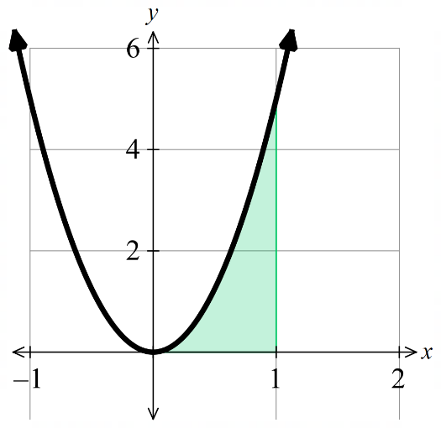
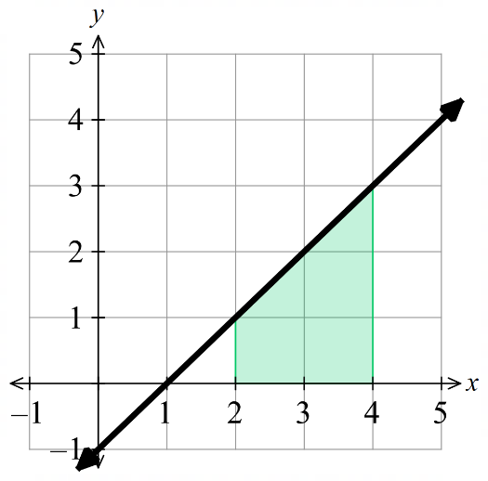
- Example Find the definite integral of a function
$$\int_{2}^{4}{\left(x-1\right)}dx$$  $$={\left[\frac{x^{2}}{2}-x\right]}_{2}^{4}$$  $$=\left(\frac{4^{2}}{2}-4\right)-\left(\frac{2^{2}}{2}-2\right)$$  $$=4$$ | $$\int_{0}^{1}{5x^{2}}dx$$  $$={\left[\frac{5x^{3}}{3}\right]}_{0}^{1}$$  $$=\frac{5}{3}-0$$  $$=\frac{5}{3}$$

- Guided Practice
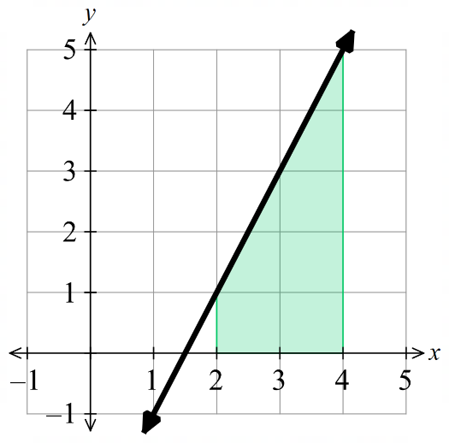  $$\int_{2}^{4}{\left(2x-3\right)}dx$$  6 | 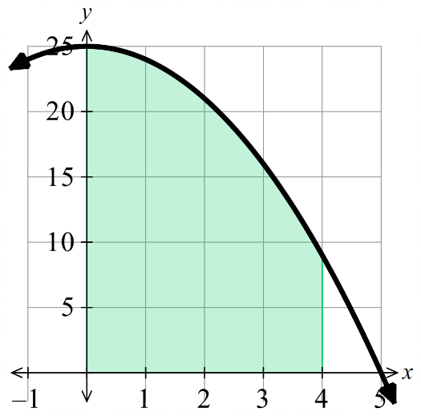  $$\int_{0}^{4}{\left(25-x^{2}\right)}dx$$  $$\frac{236}{3}$$
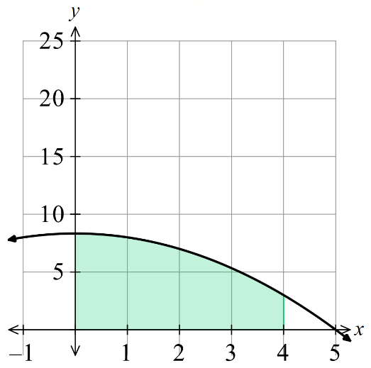  $$\int_{0}^{4}{\frac{1}{3}\left(25-x^{2}\right)}dx$$  $$\frac{236}{9}$$ | 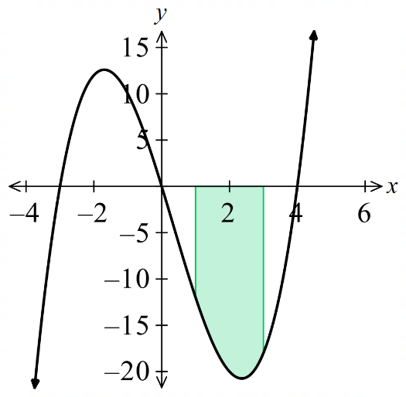  $$\int_{1}^{3}{\left(x^{3}-7x^{2}+12x\right)}dx$$  $$\frac{22}{3}$$
- Expand Brackets and Split Fractions Before Integrating
There is no reverse product rule or reverse quotient rule for integration (in the Advanced course).
You must expand products to separate terms.
You must split fractions to separate terms.

- Example Find the definite integral of a product and quotient of functions
$$\int_{1}^{6}{x\left(x+1\right)}dx=\int_{1}^{6}{\left(x^{2}+x\right)}dx$$  $$={\left[\frac{x^{3}}{3}-\frac{x^{2}}{2}\right]}_{1}^{6}$$  $$=\left(72+18\right)-\left(\frac{1}{3}+\frac{1}{2}\right)$$  $$=89\frac{1}{6}$$ | $$\int_{1}^{2}{ \frac{3x^{4}-2x^{2}}{x^{2}}}dx=\int_{0}^{3}{\left(3x^{2}-2\right)}dx$$  $$={\left[\begin{matrix} \\ x^{3}-2x \\ \end{matrix}\right]}_{1}^{2}$$  $$=\left(8-4\right)-\left(1-2\right)$$  $$=5$$

- Guided Practice
Evaluate these integrals.
$$\int_{2}^{5}{x\left(x-2\right)}dx$$  18 | $$\int_{0}^{3}{\left(x+1\right)\left(x-4\right)}dx$$  $$-\frac{33}{2}$$
$$\int_{1}^{2}{ \frac{x^{4}+6x^{3}}{x^{2}} }dx$$  $$\frac{34}{3}$$ | $$\int_{-3}^{-1}{ \frac{4x^{3}-x^{2}}{x} }dx$$  $$\frac{116}{3}$$
$$\int_{1}^{3}{ x^{-3} }dx$$  $$\frac{4}{9}$$ | $$\int_{1}^{3}{ \frac{4}{x^{2}} }dx$$  $$\frac{8}{3}$$
- Discontinuities and Integration
The definite integral is the area between a continuous curve and the $x$ axis for $x∈\left[a,b\right]$.
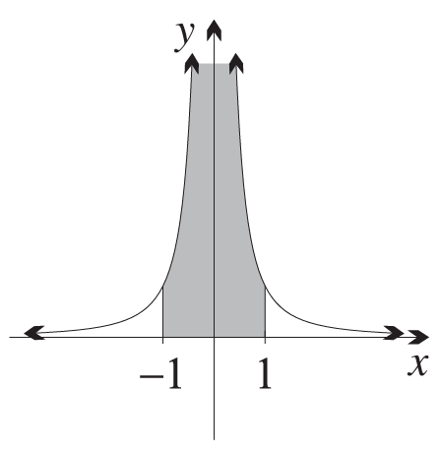
This means you cannot integrate across a discontinuity.
For example:
$$\int_{-1}^{1}{x^{-4}}dx={\left[\frac{x^{-3}}{-3}\right]}_{-1}^{1}$$
$$=-\frac{2}{3}$$

This number is clearly nonsense. The function is not defined at $x=0$, and how could you get a negative answer if the function is always positive.
Discontinuities occur when you divide by zero or take the even root of a negative.

- Identify whether you are integrating across a discontinuity
Decide whether you could use the definite integral to evaluate these definite integrals.
$$\int_{-1}^{1}{\frac{1}{x}}dx$$ | $$\int_{1}^{3}{\frac{1}{x}}dx$$ | $$\int_{-5}^{-2}{\frac{1}{x}}dx$$
$$\int_{-1}^{1}{x^{-2}}dx$$ | $$\int_{2}^{5}{x^{-2}}dx$$ | $$\int_{0}^{3}{\frac{1}{x-2}}dx$$
$$\int_{3}^{5}{\frac{1}{x-2}}dx$$ | $$\int_{0}^{3}{\frac{1}{x+1}}dx$$ | $$\int_{-1}^{4}{\sqrt{x}}dx$$
$$\int_{0}^{4}{\sqrt{x}}dx$$ | $$\int_{-3}^{1}{\frac{5}{x^{2}}}dx$$ | $$\int_{-4}^{2}{\sqrt{x+5}}dx$$
$$\int_{-2}^{4}{\sqrt[3]{x}}dx$$ | $$\int_{0}^{3}{\sqrt{9-x^{2}}}dx$$ | $$\int_{0}^{π}{\sec^{2}{x}}dx$$

Foundation
- Evaluate these definite integrals using the fundamental theorem of calculus.
$$\int_{0}^{1}{2x}dx$$  $$1$$ | $$\int_{1}^{4}{2x}dx$$  $$15$$ | $$\int_{1}^{3}{4x}dx$$  $$16$$
$$\int_{2}^{5}{8x}dx$$  $$84$$ | $$\int_{2}^{3}{3x^{2}}dx$$  $$19$$ | $$\int_{0}^{3}{5x^{4}}dx$$  $$243$$

- Evaluate these definite integrals.
$$\int_{3}^{6}{\left(2x + 1\right)}dx$$  $$30$$ | $$\int_{2}^{4}{\left(2x - 3\right)}dx$$  $$6$$ | $$\int_{0}^{3}{\left(4x + 5\right)}dx$$  $$33$$
$$\int_{2}^{3}{\left(3x^{2}- 1\right)}dx$$  $$18$$ | $$\int_{1}^{4}{\left(6x^{2}+ 2\right)}dx$$  $$132$$ | $$\int_{0}^{1}{\left(3x^{2}+ 2x\right)}dx$$  $$2$$
$$\int_{1}^{2}{\left(4x^{3}+ 3x^{2}+ 1\right)}dx$$  $$23$$ | $$\int_{0}^{2}{\left(2x + 3x^{2}+ 8x^{3}\right)}dx$$  $$44$$ | $$\int_{3}^{5}{\left(3x^{2}- 6x + 5\right)}dx$$  $$60$$

- Evaluate these definite integrals.
$$\int_{-1}^{0}{\left(1 - 2x\right)}dx$$  $$2$$ | $$\int_{-1}^{0}{\left(2x + 3\right)}dx$$  $$2$$ | $$\int_{-2}^{1}{3x^{2}}dx$$  $$9$$
$$\int_{-1}^{2}{\left(4x^{3}+ 5\right)}dx$$  $$30$$ | $$\int_{-2}^{2}{\left(5x^{4}+ 6x^{2}\right)}dx$$  $$96$$ | $$\int_{-2}^{-1}{\left(4x^{3}+ 12x^{2}- 3\right)}dx$$  $$10$$

- Evaluate these definite integrals.
$$\int_{1}^{4}{\left(x + 2\right)}dx$$  $$13.5$$ | $$\int_{0}^{2}{\left(x^{2}+ x\right)}dx$$  $$\frac{14}{3}$$ | $$\int_{0}^{3}{\left(x^{3}+ x^{2}\right)}dx$$  $$\frac{117}{4}$$
$$\int_{-1}^{1}{\left(x^{3}- x + 1\right)}dx$$  $$2$$ | $$\int_{-2}^{3}{\left(2x^{2}- 3x + 1\right)}dx$$  $$\frac{125}{6}$$ | $$\int_{-4}^{-2}{\left(16 - x^{3}- x\right)}dx$$  $$98$$

- Evaluate these definite integrals.
$$\int_{2}^{3}{x\left(2 + 3x\right)}dx$$  $$24$$ | $$\int_{0}^{2}{\left(x + 1\right)\left(3x + 1\right)}dx$$  $$18$$ | $$\int_{-1}^{1}{x^{2}\left(5x^{2}+ 1\right)}dx$$  $$\frac{8}{3}$$
$$\int_{-1}^{2}{{\left(x - 3\right)}^{2}}dx$$  $$21$$ | $$\int_{-1}^{0}{x\left(x - 1\right)\left(x + 1\right)}dx$$  $$\frac{1}{4}$$ | $$\int_{-1}^{0}{{\left(1 - x^{2}\right)}^{2}}dx7$$  $$\frac{8}{15}$$

- Evaluate these definite integrals.
$$\int_{1}^{3}{\frac{3x^{3}+ 4x^{2}}{x}}dx$$  $$42$$ | $$\int_{1}^{2}{\frac{4x^{4}- x}{x}}dx$$  $$14$$ | $$\int_{2}^{3}{\frac{5x^{2}+ 9x^{4}}{x^{2}}}dx$$  $$62$$
$$\int_{1}^{2}{\frac{x^{3}+ 4x^{2}}{x}}dx$$  $$\frac{25}{3}$$ | $$\int_{1}^{3}{\frac{x^{3}- x^{2}+ x}{x}}dx$$  $$\frac{20}{3}$$ | $$\int_{-2}^{-1}{\frac{x^{3}- 2x^{5}}{x^{2}}}dx$$  $$6$$

Development
- Evaluate these definite integrals.
$$\int_{0}^{\frac{1}{2}}{x^{2}}dx$$  $$\frac{1}{24}$$ | $$\int_{0}^{\frac{2}{3}}{\left(2x + 3x^{2}\right)}dx$$  $$\frac{20}{27}$$ | $$\int_{\frac{1}{2}}^{\frac{3}{4}}{\left(6 - 4x\right)}dx$$  $$\frac{7}{8}$$

- Evaluate these definite integrals.
$$\int_{5}^{10}{x^{-2}}dx$$  $$\frac{1}{10}$$ | $$\int_{2}^{3}{2x^{-3}}dx$$  $$\frac{5}{36}$$ | $$\int_{\frac{1}{2}}^{1}{4x^{-5}}dx$$  $$15$$
$$\int_{1}^{2}{\frac{1}{x^{2}}}dx$$  $$\frac{1}{2}$$ | $$\int_{1}^{4}{\frac{1}{x^{3}}}dx$$  $$\frac{15}{32}$$ | $$\int_{\frac{1}{2}}^{1}{\frac{3}{x^{4}}}$$  $$7$$

  - Show that $\int_{2}^{k}{3}dx=3k - 6.$
$$\int_{2}^{k}{3}dx = {\left[3x\right]}_{2}^{k}= 3k - 6$$
  - Hence find the value of $k$, given that $\int_{2}^{k}{3}dx = 18.$
$$3k - 6 = 18,$$
$$k = 8.$$

  - Show that $\int_{0}^{k}{x}dx =\frac{k^{2}}{2}.$
$$\int_{0}^{k}{x}dx = {\left[\frac{x^{2}}{2}\right]}_{0}^{k}=\frac{k^{2}}{2}$$
  - Hence find the positive value of $k$ given $\int_{0}^{k}{x}dx = 18.$
$$\frac{k^{2}}{2}= 18,$$
$$so k^{2}= 36,$$
$$k = 6 \left(k > 0\right).$$
- Find the value of $k$ if $k > 0$.
$$\int_{k}^{3}{2}dx=4$$  $$k=1$$ | $$\int_{k}^{8}{3}dx=12$$  $$k=4$$ | $$\int_{2}^{3}{\left(k-3\right)}dx=5$$  $$k=8$$
$$\int_{3}^{k}{\left(x-3\right)}dx=0$$  $$k=3$$ | $$\int_{1}^{k}{\left(x+1\right)}dx=6$$  $$k=3$$ | $$\int_{1}^{k}{\left(k+3x\right)}dx=\frac{13}{2}$$  $$k=2$$

- Evaluate these integrals.
$$\int_{1}^{2}{\frac{1 + x^{2}}{x^{2}}}dx$$  $$\frac{3}{2}$$ | $$\int_{-2}^{-1}{\frac{1 + 2x}{x^{3}}}dx$$  $$\frac{5}{8}$$

- Evaluate these integrals.
$$\int_{1}^{3}{{\left(x +\frac{1}{x}\right)}^{2}}dx$$  $$\frac{40}{3}$$ | $$\int_{1}^{2}{{\left(x^{2}+\frac{1}{x^{2}}\right)}^{2}}dx$$  $$\frac{1019}{120}$$

  - Explain why $y =$ $\frac{1}{x^{2}}$ is never negative.

$$x^{2} is never negative, so\frac{1}{x^{2}} is never negative.$$
  - The integral is negative, even though the graph is always above the $x$ axis.
Explain why the integral below is actually undefined.
$$\int_{-1}^{1}{\frac{1}{x^{2}}}dx = {\left[-\frac{1}{x}\right]}_{-1}^{1}= -1 - 1 = -2$$

The function is undefined at $x = 0$, which lies in the given interval.
Hence the integral is meaningless and the use of the fundamental theorem is invalid.
  - Without evaluating, identify which integrals are undefined.
$$\int_{0}^{2}{\frac{1}{{\left(3 - x\right)}^{2}}}dx$$ | $$\int_{2}^{4}{\frac{1}{{\left(3 - x\right)}^{2}}}dx$$ | $$\int_{4}^{6}{\frac{1}{{\left(3 - x\right)}^{2}}}dx$$
Part ii) due to integrating across the asymptote at $x=3$

